# Setup guide for Google Cloud Platform

This guide explains how to set up Google Cloud Platform (GCP) to use PyTorch 1.0.0 and fastai 1.0.2. At the end of this tutorial you will be able to use both in a GPU-enabled Jupyter Notebook environment.

**1. Sign up on Google Cloud Platform Free Tier.**

<https://cloud.google.com/free/>

**2. Upgrade to a paid account (credit card required).**

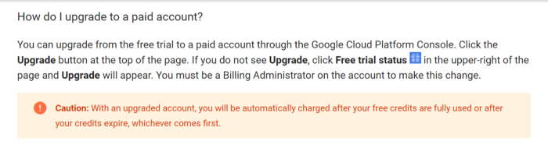

If you are unable to find an Upgrade button at this point, just continue with the next steps. The Upgrade button should appear at Step 5 below when you request for an increase in quota.

**3. Create a new project for the deep learning course course**

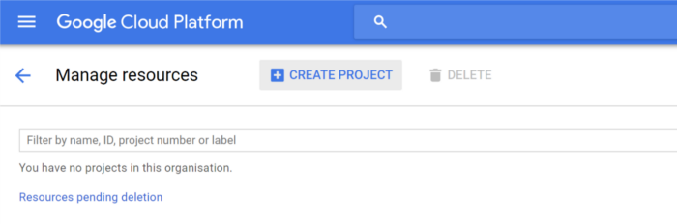

Click on “Create Project”.

**4. Request for increase in quota for GPU**

IAM & Admin → Quotas

**5. In filter type, select metric to be GPUs (all regions) and Location as Global.**

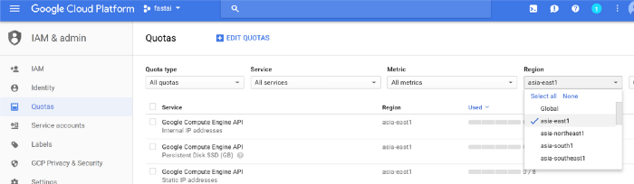

Click edit quotas and select the quota to edit (GPUs All Regions). Set the new quota limit to 1 or more. Your request may require confirmation, which Google claims typically takes two business days to get.

**6. Receive email approval of quota increase**

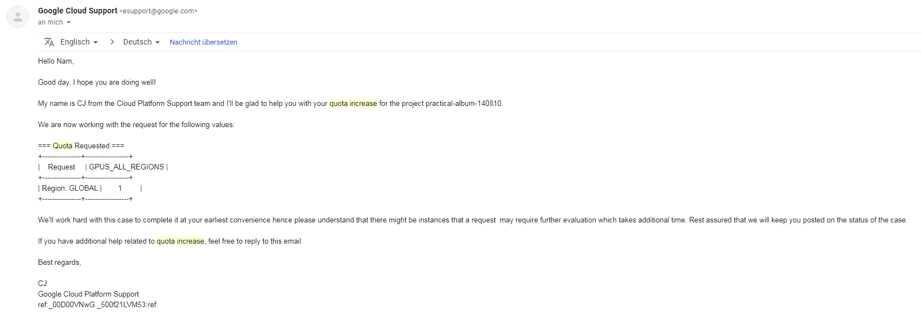

**7. Navigate to the Compute Engine -> VM-instances**

Create new instance

Give a name for your instance

Region: us-central1, Zone: us-central1-c

Machine type: n1-highmem-8

GPU type: NVIDIA Tesla P4

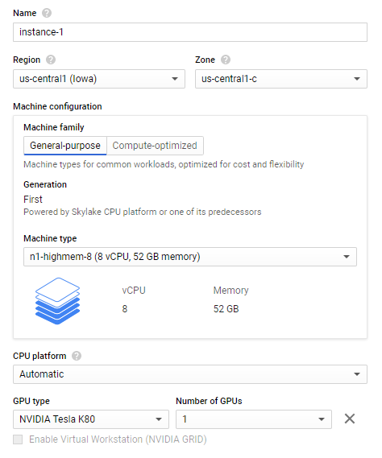

Boot disk: Deep Learning Image: PyTorch 1.1.0 and fastai m30

Boot disk type: Standard persisten disk with 200GB

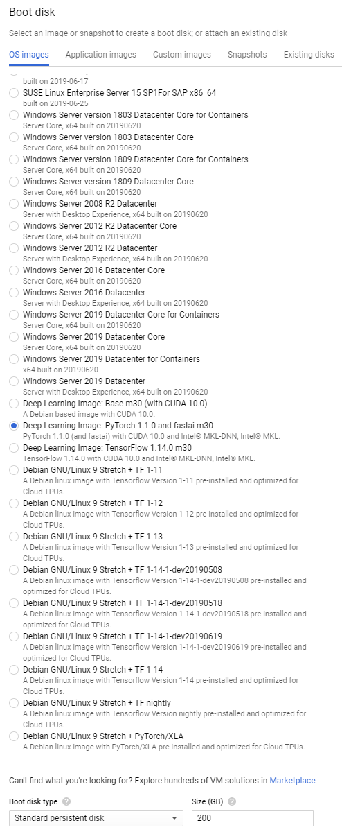

Firewall: Allow HTTP and HTTPS traffic

Preemptibility: On

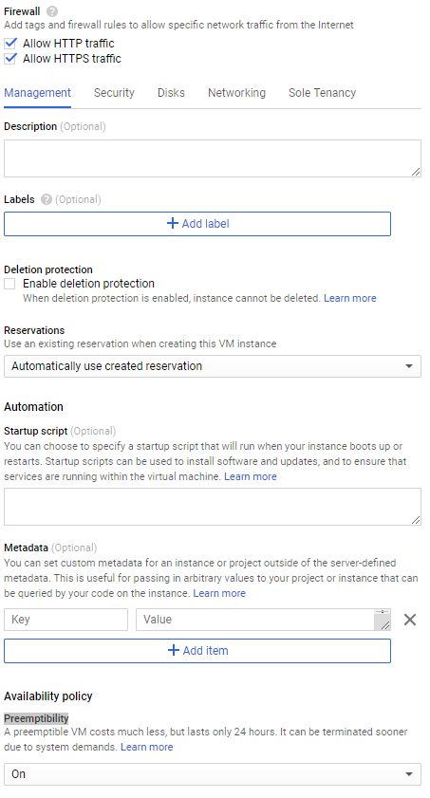

Price of your VM instace should be about $0.327 hourly

**8. Create a static IP address**

Click on the three dots besides your created VM instance and select ‘View network details

Navigate to external IP addresses and select reserve a static address

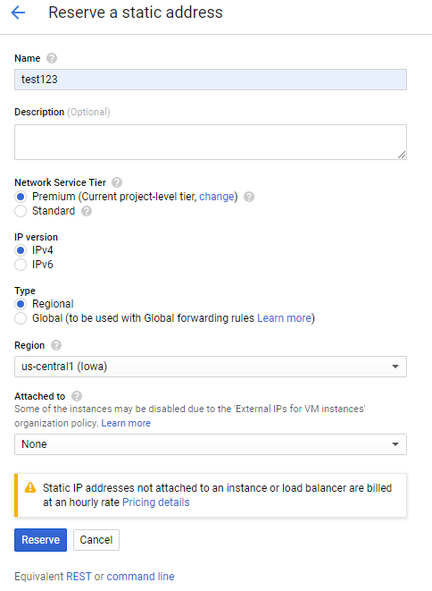

Reserve and click on change to attach IP address to your instance

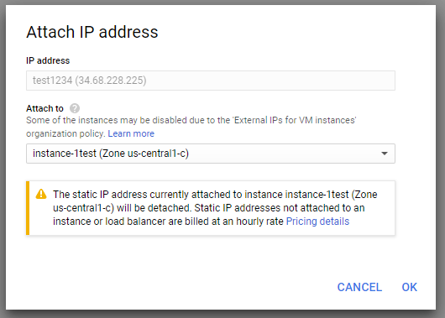

**9. Connect to the CM instance through SSH from the browser:**

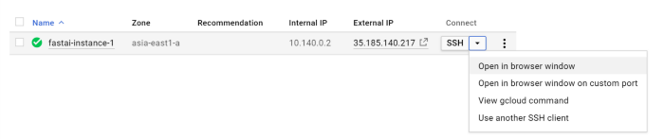

**10. Install Nvidia driver**

**11. Configure Jupyter Notebook Server**

Type in terminal:

jupyter notebook --generate-config

cd .jupyter

open your jupyter notebook config with editor of your chose, e.g. vim jupyter_notebook_config.py

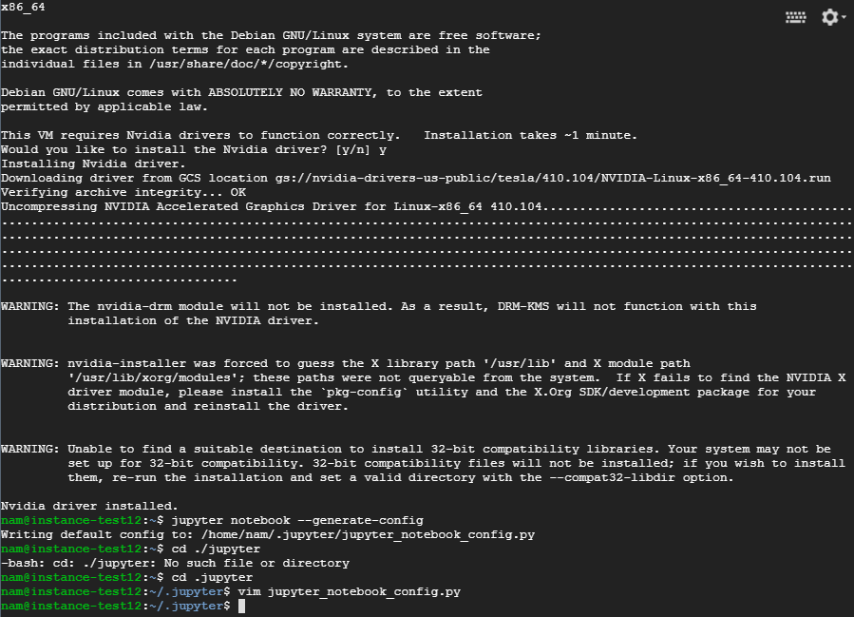

add somewhere following lines:

c.NotebookApp.ip = '0.0.0.0'

c.NotebookApp.port = 8888

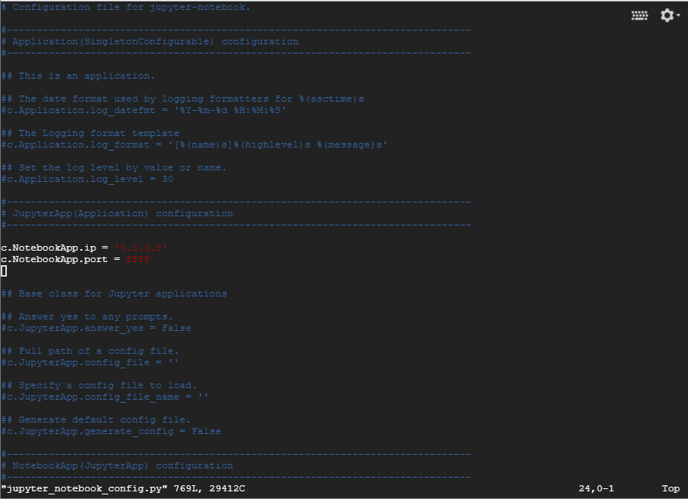

**12. Start Jupyter Notebook**

Type in terminal jupyter notebook and copy your token

Type in your browser address bar “external-ip-of-your_instance:8888”

Paste your Token and create new Password

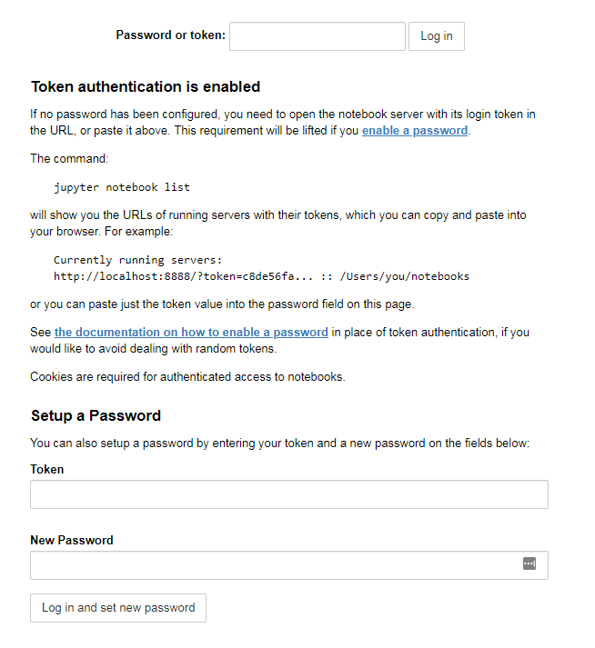

**13. Important: Remember to stop your VM instance when you are done with your notebooks or you will continue to incur charges.**

